**TECHNICAL ARCHITECTURE / STACK**

|  |  |
| --- | --- |
| Date | 18 November 2022 |
| Team ID | PNT2022TMID48304 |
| Project Name | Project - IoT Based Smart Crop Protection System for Agriculture |

**Open Source Frame Works**

Some open-source IoT frameworks are best for scalability, some other for customization, and a few others for security and easy integration.

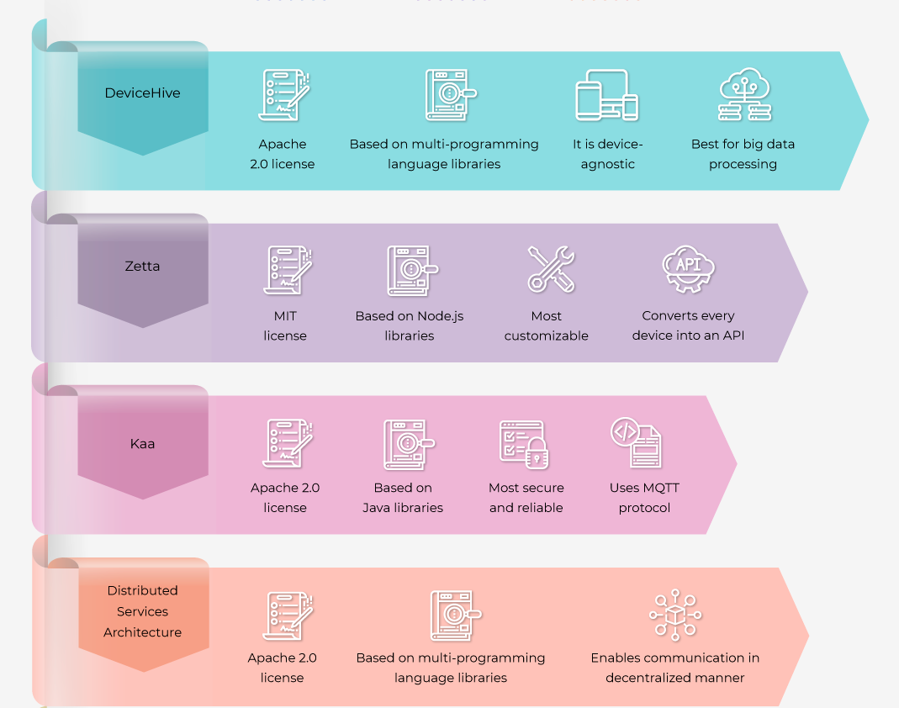

**Device Hive:**

DeviceHive is related under Apache 2.2 license, making it a reliable and secure option for creating IoT solutions. But, what makes it different from kaa its multilingual library support. DeviceHive supports libraries of various programming languages like Java, Node.js, Python, Android and iOS.

**Zetta:**

Zetta is an API-first IoT platform popularly used to develop scalable solutions. API-first in the sense that it can convert any device into an API for easy integration and connectivity. T his increases its ability to scale. Zetta is based on Node js.programming language libraries and released under MIT license.

**Kaa:**

Kaa is one of the most widely used open source IoT frameworks. It is a framework majorly based on Java libraries and released under the Apache 2.0 license. Apache provides a copy of its license for every derivative work. And this license is provided only if developers are able to provide unequivocal statements providing that the source code has been modified.

**Distributed services architecture:**

Distributed services architecture is a multilingual library-based IoT framework. It facilitates development for what can be called the most secure IoT solutions. Firstly it is released under the Apache 2.0 license that makes its reliable.